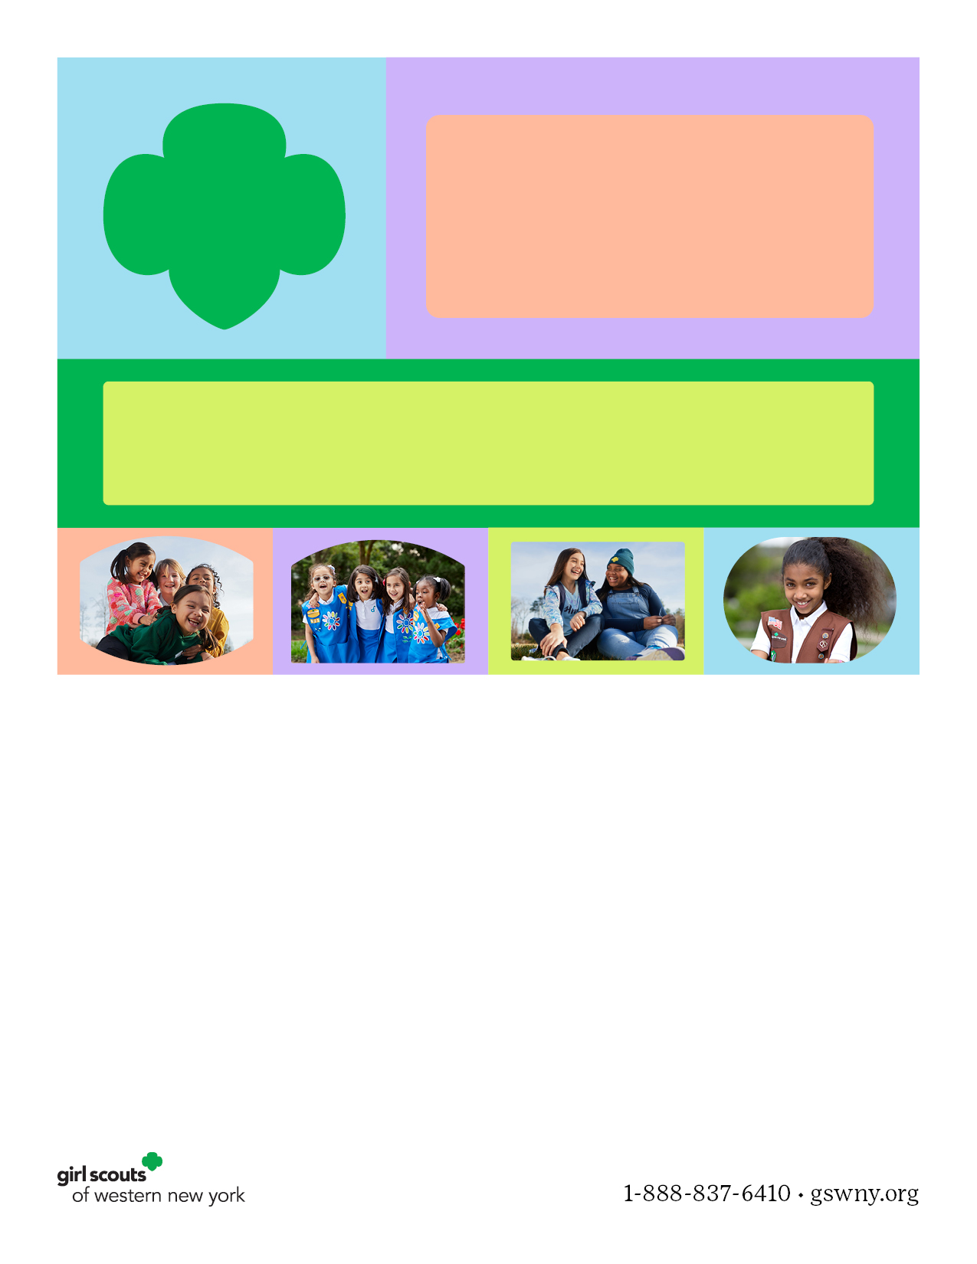

Use this space for any details about your event, contact info and more. Please keep your font in Palatino or Palatino Linotype to align with our new nationwide branding. Thank you!

Questions about using this flyer template? Please contact customercare@gswny.org or 1-888-837-6410 and your message will be forwarded to the marketing department.

Hosted by Girl Scouts of Western New York’s   
Troop # or Service Unit Name (do not remove GSWNY’s name)

Put your event   
name here