GSWNY 2024
Earth Day Challenge!

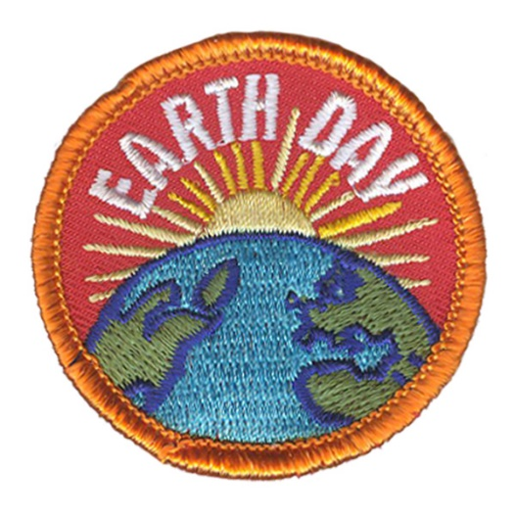
Our Girl Scout Laws asks us to make the world a better place. During the month of April, try to make our world safer and cleaner. Earn the Earth Day patch by trying at least one activity from each section below:

Climate Change:
- Explore & learn on the NASA Climate Kids website
- Ride a bike or take a walk instead of riding in the car
- Make a meatless meal one day a week

Cleaner Air:
- Grow a house plant to improve indoor air quality
- Plant trees or shrubs outside to boost air quality
- Stop unnecessary outdoor fires such as burning garbage

Reduce Solid Waste:
- Buy less. The fewer things we buy; the less trash we create. When you shop think: Do you really need it? And do you have something like it at home already?
- Use a soap bar: try buying soap in bars instead of bottles, so you won’t have to throw away the bottle
- Reuse jars and containers for storing leftovers or organizing your stuff
- Pack your lunch in a reusable container instead of one use plastics

Recycle:
- Recycle cans, plastic, glass and paper
- Donate outgrown clothes, toys, and books to a thrift shop or sale
- Composting is a good way to get rid of food scraps while making a good fertilizer for your plants. Add a mixture of green (e.g. cut grass, fruit &vegetable peel) and brown (e.g. leaves, shredded paper) waste into a bin. When broken down it can be added to your garden soil to help your plants grow
Attend a GSWNY Outdoor Program:
- Celebrate Earth Day! Earn a badge, an Earth Day patch, take a hike, and have lunch and snacks too!
  - Sunday, April 20th Celebrate Earth Day at Camp Piperwood from 10 AM -3 PM
  - Sunday, April 21st Celebrate Earth Day at Camp Windy Meadows from 10 AM – 3 PM

The patch will be available for purchase in our GSWNY Council Shops. Visit gswny.org/shop to see locations and hours, or use the contact info below to reach out directly.
Buffalo: Shop.Buffalo@gswny.org 716.935.6035 Jamestown: Shop.Jamestown@gswny.org 716.935.6040
Lockport: Shop.Lockport@gswny.org 716.935.6080 Rochester: Shop.Rochester@gswny.org 585.239.7910

